10th February 2016

**WTCC 2016 CALENDAR ADJUSTED**

Eurosports Events, promoters of the FIA World Touring Car Championship which has Japanese Tyre manufacturer as exclusive Tyre supplier has just announced an adjustment to the 2016 Calendar.

The Race of France at Paul Ricard circuit from 1st-3rd April will be the curtain raiser to the 12-event global tour.

With the inclusion of the Moscow Raceway now scheduled for June, the Russian WTCC calendar slot is now guaranteed and will take place from 10th-12th June. As a result of the changes, there has been a new date set for the WTCC’s street race spectacular in Portugal too, two weeks later than originally planned. The race will now be held from 24th-26th June.

The amended WTCC schedule for 2016 will now be submitted for final World Motor Sport Council approval.

The minor calendar adjustment will ensure WTCC Race of Portugal in Vila Real retains its status as the final event of the European season prior to the summer break. This will ensure that all logistic arrangements to transport the WTCC cars and equipment to South America by sea for WTCC Race of Argentina from 5-7 August will remain unaffected.

**WTCC 2016 Calendar (Updated)**

1-3 April 2016: FIA WTCC Race of France (Circuit Paul Ricard)

15-17 April 2016: FIA WTCC Race of Slovakia (Slovakia Ring)

22-24 April 2016: FIA WTCC Race of Hungary (Hungaroring)

7-8 May 2016: FIA WTCC Race of Morocco (Circuit Moulay El Hassan, Marrakech) S

26-28 May 2016: FIA WTCC Race of Germany (Nürburgring Nordschleife)

10-12 June 2016: FIA WTCC Race of Russia (Moscow Raceway)

24-26 June 2016: FIA WTCC Race of Portugal (Circuito Internacional de Vila Real) S

5-7 August 2016: FIA WTCC Race of Argentina (Autódromo Termas de Río Hondo)**

2-4 September 2016: FIA WTCC Race of Japan (Twin Ring Motegi)

23-25 September 2016: FIA WTCC Race of China (Shanghai International Circuit)

4-6 November 2016: FIA WTCC Race of Thailand (Chang International Circuit)**

23-25 November 2016: FIA WTCC Race of Qatar (Losail International Circuit) N

S Indicates street race; N Indicates Night Race; * subject to final FIA World Motor Sport Council approval; ** pending on signature of promoter agreement

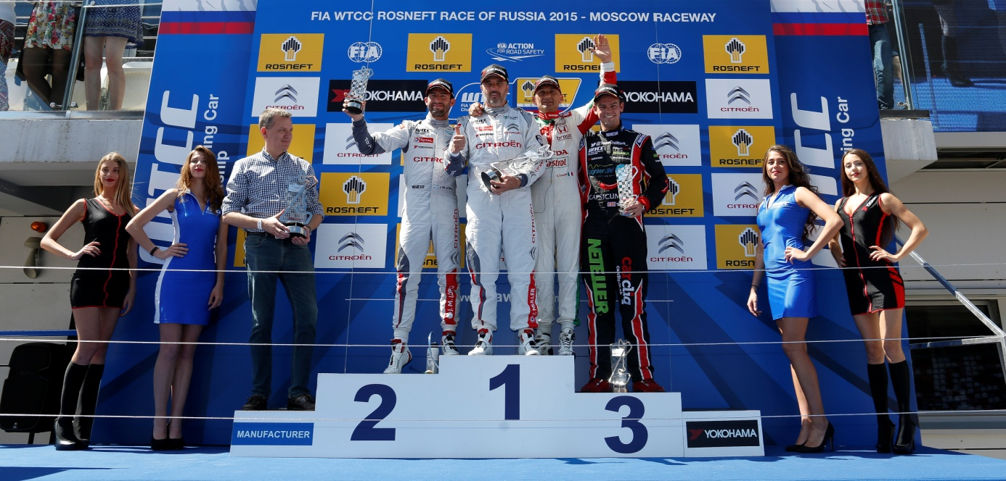

*Moscow Raceway 2015 Podium Race 1*